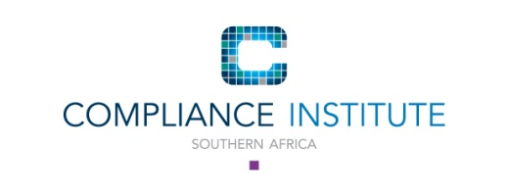

Finance Policy
Please note that a membership application/membership renewal and/or event registration is made in your personal capacity and not that of your employer. You are personally responsible for ensuring payment of any and all monies due to the Compliance Institute Southern Africa (“the Institute”).

Payment Terms for EVENTS - Conferences, Courses, (CLASSROOM AND WEB-BASED), Workshops
- Payment terms are strictly on presentation of invoice.
- No exceptions will be considered.
- Delegates will not be allowed to attend unless payment is received in full before commencement of the event.
- Any event fee still outstanding after 30 calendar days from date of invoice will result in the suspension of the membership/account.
- An event invoice still outstanding after 60 days from the date of invoice will result in the account being handed over for collection.
- The Institute will endeavour to accommodate reasonable requests to complete supplier/vendor registration forms. However, the delegate must ensure that this request is made in sufficient time for payment to be made in full before the event.
- Completion of the supplier/vendor registration forms MUST NOT be construed as an exception to the requirement for full payment before the event.
- Requests to complete supplier/vendor registration forms will NOT be accepted after the booking/registration has been submitted.
- Registration for an event is done in the delegate’s personal capacity and not that of the employer/third party. Therefore, the delegate is personally responsible for payment of the invoice.
- Members and Non-members are personally responsible for payment of their conference, course, forum, seminar, workshop, or any other fees due to the Institute.

Cancellation fees apply to all events - please refer to the Cancellation Policy andTerms and Conditions for each Event.

