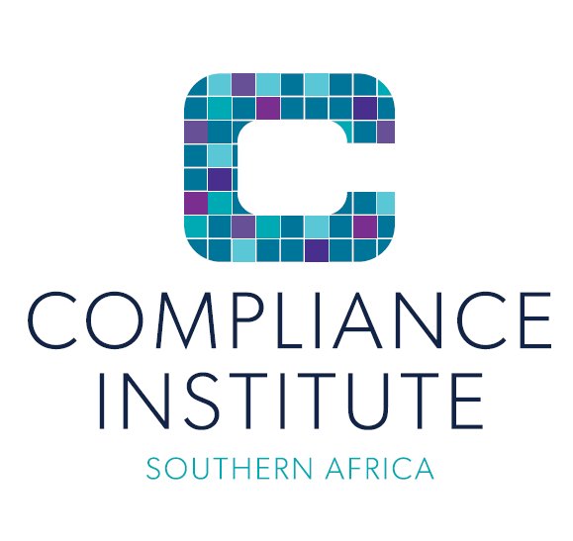

Code of Conduct for Mentors and Mentees of the Youth Mentorship Programme

All mentors and mentees enrolled with the Compliance Institute Southern Africa (‘the Institute’) undertake to adhere to this Code of Conduct.

All mentors and mentees agree to:

- Establish and commit to the modes of communication to be used (email/mobile phone or landline/text messaging/Skype/teleconferencing/face-to-face sessions)
- Establish and commit to the permitted times for these communications
- Establish and commit to the date, time, length and frequency of sessions
- Establish and commit to a suitable location for the scheduled sessions
- Make appropriate use of the online tools available on the website: shortlisting, feedback and live chat functions
- Respect the time and resources of both the mentor and mentee
- Agree on clear, appropriate and culturally sensitive boundaries to govern all interactions, physical or otherwise
- Avoid any inappropriate interactions and unsuitable conduct towards each other, such as sexual harassment, soliciting funds or financial support, or disrespecting personal and professional boundaries
- Create a safe space for all communications and conduct
- Treat all information gathered in the process of the mentorship relationship as strictly confidential

Initial:……………

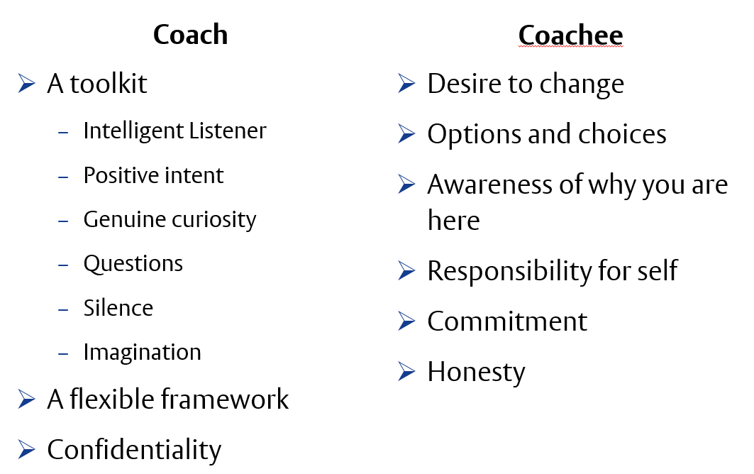

I, ……………………………………………………………………………………………….. (full name and ID number), enrolled as a ………………………………………….. (mentor / mentee) hereby acknowledge that I have read the code of conduct, and agree to uphold it to the best of my ability and knowledge.

Signed: ____________________________________

Date: ____________________________________

